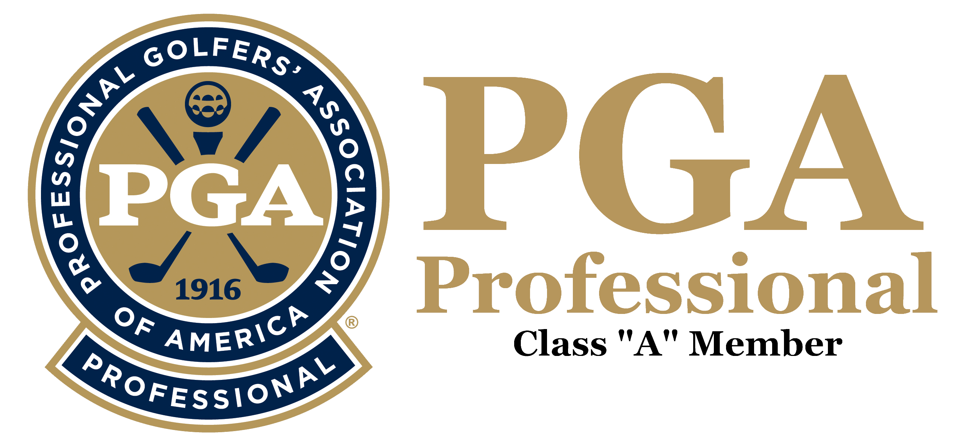
PRESENTATION
OF
QUALIFICATIONS

STAN D. CZERNO

Waynesboro, GA
401-282-0886
sdczerno@pga.com
www.pgapro1.com
Professional Experience:
April 2015 – Current | Applewood Golf Club, Keysville, GA | PGA Teaching Professional
May 2009 –Nov 2011 | Carnegie Abbey Club, Portsmouth, RI | Starter / Ranger
April 2007 – August 2007 | The Golf Pavilion, Ashaway, RI | PGA Teaching Professional
June 2006 – August 2006 | Button Hole GC, Providence, RI | PGA Teaching Professional
May 2005 – June 2005 | Fox Creek, Smyrna, GA | PGA Teaching Professional
March 1998 – May 2005 | Fairway Golf Center, Marietta, GA | PGA Teaching Professional
October 1996 – Feb 1998 | Links O’Tryon, Campobello, SC | PGA Golf Professional / Superintendent
June 1996 – Oct 1996 | Dublin CC, Dublin, GA | PGA Golf Professional / Superintendent
Sept 1993 – June 1996 | McDivots Golf Center, Alpharetta, GA | PGA Teaching Professional
July 1990 – August 1993 | Milledgeville CC, Milledgeville, GA | PGA Golf Professional
April 1982 – June 1990 | Springbrook CC, Lawrenceville, GA | PGA Golf Professional
July 1980 – April 1982 | Honey Creek CC, Conyers, GA | PGA Golf Professional / Superintendent
Oct 1977 – June 1980 | Summit Chase CC, Snellville, GA | PGA Golf Professional
July 1976 – Sept 1977 | Waynesboro CC, Waynesboro, GA | PGA Golf Professional
Dec 1973 – June 1976 | Swainsboro CC, Swainsboro, GA | PGA Golf Professional / Superintendent
Sept 1970 – Nov 1973 | Jekyll Island Club, Jekyll Island, GA | PGA Assistant Golf Professional

Professional Accomplishments:
- Rated one of "America's Top Instructors" by the Guide to America's Top Golf Instructors, 2002
- Voted Best Short Iron Player by Georgia PGA Members, 1984
- Voted Best Mid-Iron Player by Georgia PGA Member, 1985
- Georgia PGA Section Player of the Year, 1979
Professional Playing Career:
- Won the Southeastern Open at Jekyll Island CC, 1974
- Competed on Georgia PGA Challenge Cup Team, 1977 – 1988
- Tied for Low-Pro at the Green Island Pro-Am, Columbus, GA., 1977
- Won the Mary Calder Invitational at Savannah, GA., 1977
- Played on the Georgia PGA Magnolia Cup Team, 1984 – 1986
- Won the Georgia PGA Pro-President at Callaway Gardens, 1984
- Won the Pro-Lady at Brookfield West CC in 1984
- Georgia Open Pro-Am Low Pro, 66, 1984, Savannah Inn & CC, Savannah, GA
- Played in the Atlanta Classic PGA Tour Event at The Atlanta CC, 1984 – 1986
- Played in the Southern Open PGA Tour Event at Green Island CC, 1984 – 1985
- Lowest Round Recorded in qualifying for the Atlanta Classic by a Club Pro in the Georgia Section with a score of 66 at the Horseshoe Bend CC, Roswell, GA., 1986
- Won the Central Chapter Pro-Pro at Houston Lakes CC, Perry, GA., 1991
- Played on the Georgia PGA Senior Challenge Cup Team, 2001
- Nine Career Hole-in-Ones (Two in the Georgia Open and one in the Pot-of-Gold Pro-Am)
Amateur Player Highlights:
- Won the Medalist Honors in the Columbus College Invitational at Callaway Gardens, GA., 1970
- Captain of the Golf Team at Georgia Southern College, 1969 – 1970
- Awarded Golf Scholarship to Georgia Southern College, 1968
- Placed Second in the Georgia State Junior College Tournament at Forest Heights CC, Statesboro, GA., 1967 – 1968
- Placed 13th in the National Junior College Tournament at Roswell, NM., 1968
- Won the Club Championship at Potowomut GC, East Greenwich, RI., 1964 – 1968
Education:
- Completed the Henry-Griffitts Fitting School at The Atlanta Athletic Club (AAC), 1995
- Bachelor of Science in Education, Georgia Southern College, 1970
- Associate of Arts Degree, Brewton Parker College, Mt. Vernon, GA., 1968
- Bishop Hendricken HS, Warwick, RI., Class of 1962

